**Ex. No. 10 Alarm Clock - Android Application**

**Haricharan Bharathi**

**205001043**

Develop an Alarm Clock Android Application.

1. Use permission for WAKE_LOCK.

2. Have a TimePicker component followed by a ToggleButton to select time and Alarm On / Off. 3. Use the AlarmManager to set the alarm and send notification on alarm trigger. 4. Perform 3 different notifications

a. Show a message to user in the activity UI

b. Play the alarm ringtone

c. Send an Android notification message

*activity_main.xml*

<?xml version="1.0" encoding="utf-8"?>

<RelativeLayout xmlns:android="http://schemas.android.com/apk/res/android" xmlns:app="http://schemas.android.com/apk/res-auto"

xmlns:tools="http://schemas.android.com/tools"

android:layout_width="match_parent"

android:layout_height="match_parent"

tools:context=".MainActivity">

<TimePicker

android:layout_width="wrap_content"

android:layout_height="wrap_content"

android:id="@+id/time"

/>

<ToggleButton

android:id="@+id/set"

android:layout_width="150dp"

android:layout_height="50dp"

android:layout_below="@+id/time"

android:layout_marginLeft="130dp"

/>

</RelativeLayout>

*display.xml*

<?xml version="1.0" encoding="utf-8"?>

<androidx.constraintlayout.widget.ConstraintLayout

xmlns:android="http://schemas.android.com/apk/res/android"

xmlns:app="http://schemas.android.com/apk/res-auto"

android:layout_width="match_parent"

android:layout_height="match_parent">

<TextView

android:id="@+id/textView"

android:layout_width="wrap_content"

android:layout_height="wrap_content"

android:text="Close App to turn off alarm!"

android:padding="50dp"

android:textSize="20dp"

app:layout_constraintStart_toStartOf="parent"

app:layout_constraintTop_toTopOf="parent" />

</androidx.constraintlayout.widget.ConstraintLayout>

*MainActivity.java*

package com.example.alarm;

import androidx.appcompat.app.AppCompatActivity;

import android.app.AlarmManager;

import android.app.NotificationChannel;

import android.app.NotificationManager;

import android.app.PendingIntent;

import android.content.Intent;

import android.os.Build;

import android.os.Bundle;

import android.text.format.Time;

import android.view.View;

import android.widget.Button;

import android.widget.TimePicker;

import android.widget.Toast;

import android.widget.ToggleButton;

import com.example.alarm.databinding.ActivityMainBinding; import java.util.Calendar;

public class MainActivity extends AppCompatActivity { private ActivityMainBinding binding;

@Override

protected void onCreate(Bundle savedInstanceState) { super.onCreate(savedInstanceState);

setContentView(R.layout.*activity_main*);

binding = ActivityMainBinding.*inflate*(getLayoutInflater()); setContentView(binding.getRoot());

createNotificationChannel();

ToggleButton b1 = findViewById(R.id.*set*);

TimePicker t1 = findViewById(R.id.*time*);

t1.setIs24HourView(true);

b1.setOnCheckedChangeListener((buttonView, isChecked) -> {

if (isChecked) {

setAlarm();

} else {

cancelAlarm();

}

});

}

private void createNotificationChannel() {

if(Build.VERSION.*SDK_INT* >= Build.VERSION_CODES.*O*) {

CharSequence name = "alarm";

String desc = "Channel for alarm";

int importance = NotificationManager.*IMPORTANCE_HIGH*;

NotificationChannel channel = new NotificationChannel("alarm", name, importance);

channel.setDescription(desc);

NotificationManager notifs =

getSystemService(NotificationManager.class);

notifs.createNotificationChannel(channel);

}

}

public void setAlarm() {

TimePicker timePicker = findViewById(R.id.*time*);

AlarmManager alarm = (AlarmManager) getSystemService(*ALARM_SERVICE*);

Intent intent = new Intent(this, AlarmReceiver.class);

PendingIntent pendingIntent =

PendingIntent.*getBroadcast*(this.getApplicationContext(), 234, intent, PendingIntent.*FLAG_IMMUTABLE*);

int hour = timePicker.getHour();

int minute = timePicker.getMinute();

Calendar calendar = Calendar.*getInstance*();

calendar.set(Calendar.*HOUR_OF_DAY*, hour);

calendar.set(Calendar.*MINUTE*, minute);

calendar.set(Calendar.*SECOND*, 0);

long triggerTime = calendar.getTimeInMillis();

int timeInSec = 1;

alarm.set(AlarmManager.*RTC_WAKEUP*, triggerTime, pendingIntent); Toast.*makeText*(this, "Alarm set for " + hour + ":" + minute, Toast.*LENGTH_SHORT*).show();

}

public void cancelAlarm() {

AlarmManager alarm = (AlarmManager) getSystemService(*ALARM_SERVICE*);

Intent intent = new Intent(this, AlarmReceiver.class);

PendingIntent pendingIntent =

PendingIntent.*getBroadcast*(this.getApplicationContext(), 234, intent, PendingIntent.*FLAG_IMMUTABLE*);

if(alarm != null) {

alarm.cancel(pendingIntent);

}

Toast.*makeText*(this, "Alarm unset!", Toast.*LENGTH_SHORT*).show(); }

}

*AlarmReceiver.java*

package com.example.alarm;

import static androidx.core.content.ContextCompat.*startActivity*;

import android.app.AlarmManager;

import android.app.Notification;

import android.app.NotificationChannel;

import android.app.NotificationManager;

import android.app.PendingIntent;

import android.content.BroadcastReceiver;

import android.content.Context;

import android.content.Intent;

import android.content.pm.PackageManager;

import android.media.Ringtone;

import android.media.RingtoneManager;

import android.net.Uri;

import android.os.Build;

import android.widget.Toast;

import androidx.appcompat.app.AppCompatActivity;

import androidx.core.app.ActivityCompat;

import androidx.core.app.NotificationCompat;

import androidx.core.app.NotificationManagerCompat;

public class AlarmReceiver extends BroadcastReceiver {

static Uri *alarmrt1* =

RingtoneManager.*getDefaultUri*(RingtoneManager.*TYPE_ALARM*);

@Override

public void onReceive(Context context, Intent intent) {

Toast.*makeText*(context, "INSIDE WOHOOO", Toast.*LENGTH_LONG*).show();

Intent i = new Intent(context, In.class);

intent.setFlags(Intent.*FLAG_ACTIVITY_NEW_TASK* |

Intent.*FLAG_ACTIVITY_CLEAR_TASK*);

PendingIntent p = PendingIntent.*getActivity*(context, 0, i, PendingIntent.*FLAG_IMMUTABLE*);

NotificationCompat.Builder builder = new

NotificationCompat.Builder(context, "alarm")

.setSmallIcon(R.drawable.*ic_launcher_foreground*)

.setContentTitle("Your Alarm is going off!!!")

.setContentInfo("You set this alarm!")

.setAutoCancel(true)

.setDefaults(NotificationCompat.*DEFAULT_ALL*)

.setPriority(NotificationCompat.*PRIORITY_HIGH*)

.setContentIntent(p);

NotificationManagerCompat notifications =

NotificationManagerCompat.*from*(context);

if (ActivityCompat.*checkSelfPermission*(context,

android.Manifest.permission.*POST_NOTIFICATIONS*) !=

PackageManager.*PERMISSION_GRANTED*) {

return;

}

else {

notifications.notify(123, builder.build());

}

Ringtone ringtone =

RingtoneManager.*getRingtone*(context.getApplicationContext(), *alarmrt1*); //Toast.makeText(context, ringtone.toString(),

Toast.LENGTH_SHORT).show();

intent.putExtra("RINGTONE_URI", *alarmrt1*);

ringtone.play();

}

public static Uri getInstant() {

return *alarmrt1*;

}

}

*In.java*

package com.example.alarm;

import android.content.Intent;

import android.media.Ringtone;

import android.media.RingtoneManager;

import android.net.Uri;

import android.os.Bundle;

import android.widget.Toast;

//ce3c069

import androidx.appcompat.app.AppCompatActivity;

public class In extends AppCompatActivity {

@Override

protected void onCreate(Bundle savedInstanceState) {

super.onCreate(savedInstanceState);

setContentView(R.layout.*display*);

Intent intent = getIntent();

Uri ringtoneUri = intent.getParcelableExtra("RINGTONE_URI"); Ringtone ringtone = RingtoneManager.*getRingtone*(In.this, ringtoneUri);

//Toast.makeText(In.this, ringtone.toString(),

Toast.LENGTH_SHORT).show();

if (ringtone.isPlaying()) {

//Toast.makeText(In.this, "yes", Toast.LENGTH_SHORT).show(); ringtone.stop();

}

else {

//Toast.makeText(In.this, "no", Toast.LENGTH_SHORT).show(); }

}

}

*AndroidManifest.java*

<?xml version="1.0" encoding="utf-8"?>

<manifest xmlns:android="http://schemas.android.com/apk/res/android" xmlns:tools="http://schemas.android.com/tools">

<uses-permission android:name="android.permission.POST_NOTIFICATIONS" /> <uses-permission android:name="android.permission.WAKE_LOCK" /> <uses-permission android:name="android.permission.VIBRATE" />

<application

android:allowBackup="true"

android:dataExtractionRules="@xml/data_extraction_rules"

android:fullBackupContent="@xml/backup_rules"

android:icon="@mipmap/ic_launcher"

android:label="@string/app_name"

android:roundIcon="@mipmap/ic_launcher_round"

android:supportsRtl="true"

android:theme="@style/Theme.Alarm"

tools:targetApi="31">

<activity

android:name=".MainActivity"

android:exported="true">

<intent-filter>

<action android:name="android.intent.action.MAIN" />

<category android:name="android.intent.category.LAUNCHER" /> </intent-filter>

</activity>

<activity android:name=".In"

android:exported="false"

/>

<receiver android:name=".AlarmReceiver"

/>

</application>

</manifest>

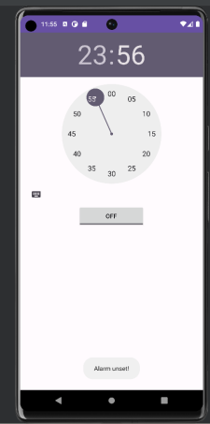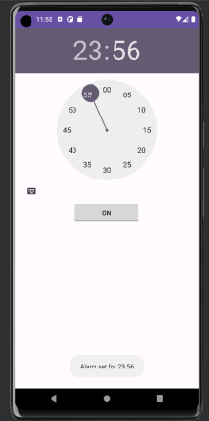

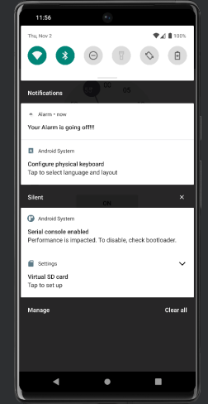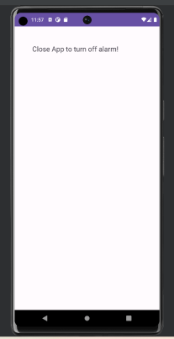

**Best Practices**

1. Keep the index form clean and uncluttered.

2. Use default ringtone as it is known by everyone.

3. Ensure the form works on various mobile devices.

**Learning Outcomes**

1. Learnt how to use UI Elements for Android App development.

2. Learnt how to use Phone shared storage.